

**Department of Computing**

**BS Computer Science**

**NASTP Institute of Information Technology**

**Submitted By:** Maisum abbas (023)

**Submitted To:** Sir Ibaad Babar

**Semester:** II

**Session:** Fall - 2024

**Subject:** Data Structures

**Date of submission:** 18 Oct 2025

**Lab Report 3**

**Task1:**  
Created the static array and using loop to find sum and average of whole array

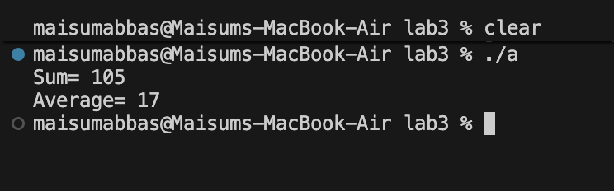

**Task2:**

First ask the user to tell size of array and and populate it by multipling by 10 and then ask the user for the number to find using linear and binary function. Linear find by going through all the array in a sequence. Binary find by dividing it and do it until number is find

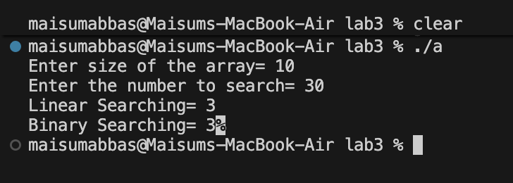

**Task3:**

Using the rand() function to populate the array then sort using selection and insertion method and tell how much swaps are done during its life cycle

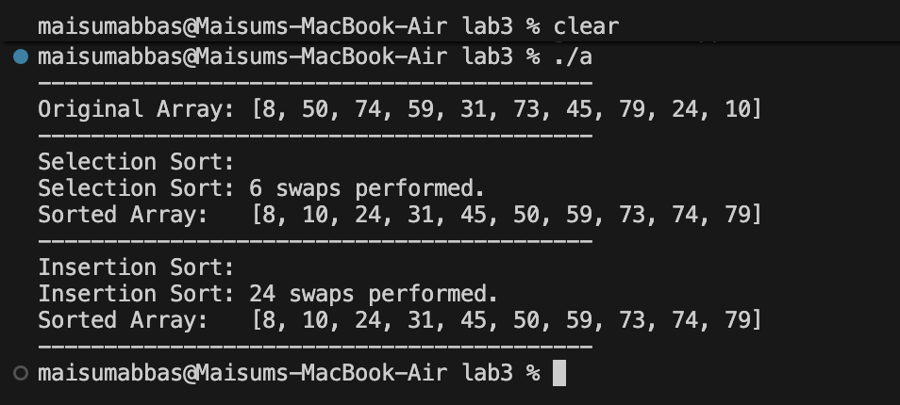

**Task4:**

Copy all the the data from given file and then put in obj . Then created the file and put the sorted data in to it which make the data in sorted form

